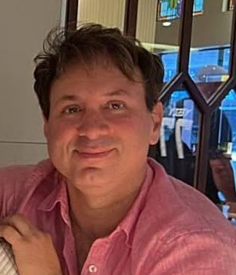

[](http://www.google.com.au/url?sa=i&source=images&cd=&cad=rja&docid=5WWO1RKO9DOMDM&tbnid=0HXnJDVgBYAGsM:&ved=0CAgQjRwwAA&url=http://www.jackcobben.nl/?p=1091&ei=xEZWUZYVwYWQBd6VgPgK&psig=AFQjCNEq-QbPl01mS0axcQLOpQyCmDRoEQ&ust=1364695108030562)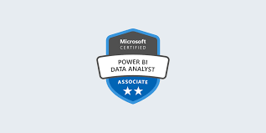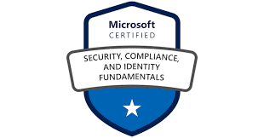 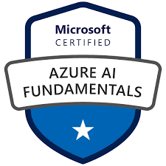

# Education

Masters in ICT

University of Sunshine Coast

2025| QLD, Australia

Graduate Certificate in ICT

University of Sunshine Coast

2023| QLD, Australia

**Certificate IV in IT**

TAFE New South Wales

2017| NSW, Australia

**Advanced Diploma in Mathematics & Physics**, Secondary Education

1998| THE, IRAN

# Certificates

* **Microsoft Certified AI f**undamental **-AI 900, 2024**
* **M**icrosoft **C**ertified in **Cybersecurity –** SC 900, **2024**
* **IT Python Specialist, 2023**
* **Microsoft Certified Solutions Associate, Australia, 2012**
* **M**icrosoft **S**ystems **E**ngineer **2008**
* **M**icrosoft **C**ertified **IT P**rofessional **(MCITP), Dubai, 2010**
* **Microsoft Certified System Engineer (MCSE) (Engineer Specialist), 2000/2003/2008**

# AWARD-WINNING HIGHLY SKILLED TECHNOLOGY PROFESSIONAL

# Australian and International experience in the design and implementation

# of company software solutions with a strong client focus

# Contact

Reza(Richard)

Kochesfehani(Nejad)

ICT System Engineer

***“A passion for supporting businesses to reduce their costs using information technology.”***



**0451442930**

**mrh.mcitp@hotmail.com**

**15 Kooraban Cres, Nth** **Kellyville** [**LinkedIn**](https://www.linkedin.com/in/richard-nejad-0263492a/)

[**Microsoft Online Transcript**](https://learn.microsoft.com/en-us/users/rezanejad-5436/transcript/7xoo1uzwq5o4k69)



# Professional Overview

Dynamic and results-oriented Microsoft Infrastructure Engineer with over 16+ years of global expertise in creating and optimising high-availability Wintel/Cloud platforms (Azure/AWS/Power Platform). Demonstrated history of providing game-changing IT solutions: lowered infrastructure costs by 90% through strategic cloud move and virtualisation; saved $400,000 by creating and hosting more than 135 optimised websites; and automated processes using PowerShell scripts. Integrates profound technical proficiency in Microsoft systems architecture with robust leadership in Agile methodologies, security compliance, and cross-functional team management to enhance operational efficiency and achieve technological outputs aligned with business objectives.

* **Award-Winning Expertise:** Acknowledged at prestigious international technology conferences in Spain, France, and Dubai for exemplary contributions to innovation in information technology (IT) and outstanding performance.
* **Mastery of Technology:** Microsoft Certified Solutions Expert with expertise in virtualisation (VMware, Hyper-V), data analytics (Python, Power BI, Excel) cloud computing (Azure, Amazon Web Services), machine learning intermediate in modelling (Python, Jupiter, VS and network security (Cisco and Azure).
* **Impact on the Business:** Led IT projects that resulted in a 45% increase in revenue and a 70% reduction in expenses via the successful implementation of key IT changes.
* **Leadership and Training:** Capable of providing technical training and leadership to teams, as well as mentoring t**eams and customers on Microsoft Office 365,** Windows OS, and sophisticated IT frameworks.

With a commitment to quality and innovation, this individual is passionate about leveraging advanced technology to enhance efficiency, security, and organisational growth.

**Look GitHub for Portfolio**

[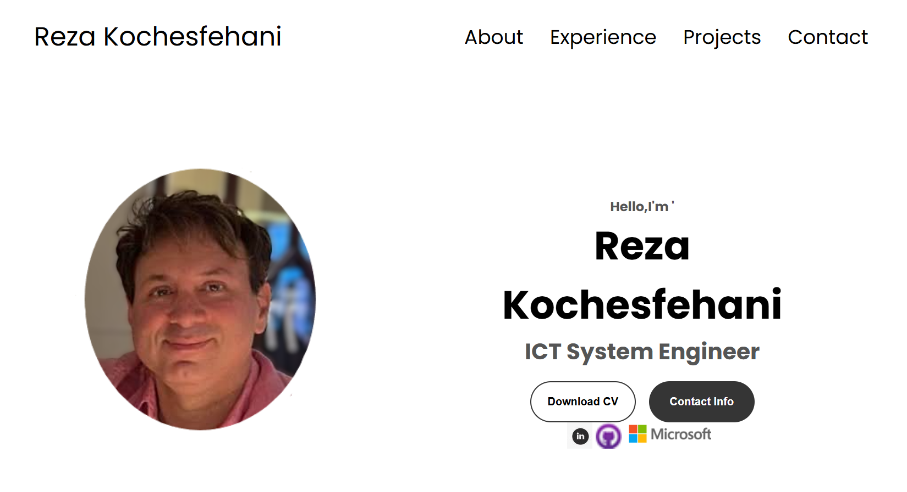](https://reza-nejad1975.github.io/portfolio/)

# additional INFORMATION

**Status** Australian Citizen

**Interests:** Playing piano, ping pong, swimming and researching new technology

**Languages:** English and Persian

**References:** Available on request

# Training Courses

* Power BI, Python, Jupiter and ML Modelling (UniSC Australia, 2022-2024)
* Microsoft Security and CCNA (Microsoft Company, Turkey, 2004)
* Infrastructure, Microsoft, Malaysia, 2002
* Active Directory, Exchange, ISA Server (Malaysia, 2001–2004)
* Advance Server 2021+Windows 11 online
* Self-study day by bay in Microsoft eLearning to keep UpToDate my knowledge

# KEY STRENGTHS AND QUALITIES

* **Strong client focus,** intuitive, good listening skills, fast learner
* **Highly organised** – able to prioritise, time-manage, work underpressure / meet deadlines and make decisions
* **High level of technical expertise –** development, support, troubleshooting and maintenance
* **Strategic thinker –** analytical research focused, results-driven.

# Carrey summary

|  |  |
| --- | --- |
| IT Infrastructure Manager, IT Service Link, Sydney-Epping (Solo Trader) | 2013-CUR |
| IT Field Support Engineer, Bios Computers, Leichhardt | 2012 - 2013 |
| IT Field Support Engineer, Funeral and Memorial Services Pty Ltd, Guildford | 2010 -2012 |
| Support Manager/Network Systems Engineer, FaraGostar Co, Dubai/UAE/Tehran | 2006 - 2010 |
| Network Engineer, Shampoo Cedr Sehat Co, Tehran, Iran | 2003 - 2006 |

[](http://www.google.com.au/url?sa=i&source=images&cd=&cad=rja&docid=5WWO1RKO9DOMDM&tbnid=0HXnJDVgBYAGsM:&ved=0CAgQjRwwAA&url=http://www.jackcobben.nl/?p=1091&ei=xEZWUZYVwYWQBd6VgPgK&psig=AFQjCNEq-QbPl01mS0axcQLOpQyCmDRoEQ&ust=1364695108030562) 

# Certificates

* **M**icrosoft **C**ertified **T**echnology **S**pecialist **(MCTS), Dubai, 2010**
* **M**icrosoft **C**ertified **P**rofessional **(MCP) C#.Net, Ankara, 2008**
* **M**icrosoft **C**ertificate **S**ystem **A**dministrator **(MCSA),** **2000/2003/2008**
* **(MCP) M**icrosoft **C**ertified **P**rofessional **2004**

# Skills

* Communication
* Teamwork
* Critical thinking
* Time management
* Leadership
* Adaptability
* Project Management

# computer Skills

**Operation Systems:** Windows NT/98/2000/XP/7/8/10/11

**Server OS:** Windows Server 2000/2003/2008/2012/2016/2019

**SBS:**2003/2008/2012/2016

**Exchange Server:** 2000/2003/2007/2010/2012/2016/ 2019

**MS Office 365**

**Citrix**, **XenApp Server**, **XenApp** **Desktop**

**Linux Red Hat** **Enterprise server 4,5**

**SQL Database:** MS SQL Server, 2000, 2005, 2008,2012

**Software:** Visual Studio, C#.Net, SharePoint, Delphi7, PHP4, HTML, CSS, WordPress CMS, Joomla CMS, The WIX Development site, Python, Jupiter

**PM Apps:** MS Project, Project in a Box

# computer Skills

**Cisco Switches:** Catalyst 2960, 2670, 3560, 3750 & ISR 1800, 1900, 2800, 2900. **Jupiter** Ex Series, 2200

**Network Device:** Wired and Wireless Adapters, Switches, Access Points, Wired/Wireless Routers, Firewall, VPN, LAN, WAN

**VPN and Virtualisation:** ESXi, vSphere, Hyper-V

SCE 2010/2012/2016/2019, SCDPM2010/2016/2019

**Remote skills:** RDP, VNC and TeamViewer, Google remote desktop

**Anti-Virus:** Bit defender, Symantec Endpoint Security, Kaspersky Antivirus, Avira Antivirus, File Server Security and Symantec Antivirus

**Infrastructure:** Active Directory infrastructure

**Hardware recovery and Assembling Servers and PC**

**Cloud Computing:** Google, Azure, Amazon

**Microsoft Team** Video Conferencing and project controlling

**Zoom** conferencing and video recording for training and support team

### **Wintel Support Engineer**

### Bios Computers, Leichhardt | 2012 – 2013

An Australian-owned company providing a full range of IT management and support to businesses. Bios are experts in total IT management and design - install, measure, and monitor networks to ensure reliable and efficient operations. Clients include LJ Hooker, Demlakian, Cash Stop, ABC Corporation, Hugh Meagher and Associates, and Alliance Francaise de Sydney. Reporting to the Managing Director.

**Key Responsibilities**

* Designing, implementing, installing, supporting, and maintaining Migrant AD and DNS from Windows 2003 to Windows Server 2008 and network communications systems.
* Implementing, installing, and supporting VMware ESXi 4.1, Virtualisation, Forefront 2010, and Private cloud with Hyper-v

# Work Experience

### **IT Field Infrastructure Support Engineer**

### IT Services Link, Sydney | 2013 – Current

IT Services Link is an Australian IT solutions provider specialising in customised business technology services. Their expert team delivers comprehensive IT management, network installation and monitoring, and professional website design solutions. The company proudly serves clients including Transit Systems NSW, Baharestan Exchange, Cash Stop, Dental Advance Care & Associates, and Music School Francoise in Sydney

**Key Responsibilities**

* Designed, implemented, and maintained Active Directory (AD), DNS, RDP, and OU policies for Windows Servers 2012, 2016, and 2019.
* Provided Level 3 Wintel support, resolving issues with printing, domain joining, AD accounts, and messaging services.
* Developed and upgraded websites using WordPress, PHP, HTML, Python, and MySQL.
* Troubleshot print servers, workstations, and systems via RDP, TeamViewer, and Google Remote Desktop.
* Configured and maintained servers, printers, firewalls, storage devices, and Symantec Enterprise Vault.
* Delivered hardware/software upgrades for over 3000 users, including Windows 7/10/11 and MS Office 365.
* Conducted weekly client training on Windows 10, MS Office 2019, and Office 365.
* Designed and implemented VLANs, NATs, ACLs, advanced routing, and layer 2/3 switching using Cisco hardware.
* Analysed network security strategies and recommended tailored solutions.
* Managed IT services such as AD, DNS, DHCP, FTP, mail, backup, and antivirus systems.

**Key Achievements**

* Maintained a strong reputation for client satisfaction, ensuring repeat business, especially during COVID-19.
* Streamlined workflows using Service Link Cloud computing for efficient, timely service delivery.
* Reduced physical server costs by 90% through cloud services, clustering, and remote application deployment.

**C**

# Core Competencies

**Scripting & Automation:** PowerShell, Python, HTML, PHP

**Cloud & Virtualisation:** Azure, AWS, Hyper-V, VMware

**Infrastructure & Platforms:** Windows Server 2000–2019, Active Directory, Exchange, Power Platform, Server 2000-2022, DNS, DHCP, IIS

**Security & Compliance**: Microsoft SC-900, security baselines, CIS, NIST standards, Entra ID

**DevOps & IaC**: GitHub, Terraform (basic), Azure DevOps, CI/CD pipelines

**Monitoring & High Availability**: Azure Monitor, Failover Clustering, SAN, VDI, Citrix XenApp

**Project & Agile Methodologies**: Agile, MSP, Service Link, Jira

### **IT Field System Engineer**

### Funerals and Memorial Services, Sydney | 2010-2012

Funerals and Memorials Pty Ltd is an Australian-owned company that provides funeral services to clients. Reporting to -the CEO - this role is part of the business's backend support services.

**Key Responsibilities**

* Designed, implemented, and migrated Active Directory (AD) and DNS from Windows Server 2003 to 2008, managing a team of 8, including network engineers and IT managers.
* Installed and maintained Forefront 2010, Hyper-V, VMware ESXi 4.1, Citrix XenApp server, and Virtual Desktop Interface (VDI) for funeral applications.
* Provided Level 1–3 support for hardware, software, printing, domain connectivity, and messaging services.
* Clustered storage area networks (SANs) with resources like HP DL-180 and extended them to remote locations for backup and archival.
* Designed and developed websites using WordPress, PHP, and HTML.
* Installed and secured Cisco routers, switches, firewalls, Microsoft ISA Server 2006, xDSL modems, and other network equipment.
* Configured and administered Exchange Server 2010, domain controllers, print servers, and various IT devices.
* Delivered client training sessions on Windows XP/7 and MS Office 2007/2010.
* Planned and executed upgrades for over 300 computers to Windows 7 and MS Office 2007/2010.
* Implemented VLANs, NATs, ACLs, advanced routing, and layer 2/3 switching using Cisco hardware.
* Analysed network security strategies and proposed tailored solutions.
* Managed IT services such as AD, DNS, DHCP, FTP, mail, backup, and antivirus.
* Rebuilt, upgraded, and developed hardware/software for user-level support.
* Diagnosed and resolved server and workstation issues.

**Key Achievements**

* Enhanced business operations by analysing and implementing effective IT solutions, driving consistent growth.
* Saved over $400,000 by creating 135 websites, managing 255 domains, and transitioning hosting services, including key sites like [**www.cosmopolitanfunerals.com.au**](http://www.cosmopolitanfunerals.com.au)**,** [**www.orthadox.com.au**](http://www.orthadox.com.au) and [**www.jamesmurray.com.au**](http://www.jamesmurray.com.au) **.**
* Designing, implementing, installing, supporting, and maintaining Exchange Server 2010
* Liaising and working together with other staff members to solve problems for clients quickly and effectively
* Designing and implementing new websites with word press, PHP, and HTML
* Developing new, rebuilding, or upgrading Hardware and Software to support end users at the user level
* Troubleshooting/analysis of servers, workstations, and associated systems

**Key Achievements**

* Developing an excellent internal/external client reputation, resulting in generating strong repeat business.
* Contributing to employer revenue by 65% and client cost savings by 70%.
* Reduced physical server costs by 90% through virtualisation, clustering, and deploying remote applications for customer funeral arrangements.

### **Support Manager and System Administrator**

### Faragostar, Dubai- Cedr, Tehran | 2003-2010

While working with FaraGostar Co and Shampoo Cedr Sehat Co from 2003 to 2010, I honed my skills in information technology infrastructure, network security, and system administration. During my tenure at FaraGostar (2006–2010), I engineered and executed Management Information Systems, devised SharePoint solutions, oversaw virtualisation using VMware and Citrix, and fortified network security, resulting in an annual cost savings of $900,000 and an increase of 7000 users in the client base. At Shampoo Cedr Sehat Co (2003–2006), I oversaw secure LAN/WAN networks, maintained domain controllers, and provided IT support for more over 300 users, adopting stringent security protocols and enhancing operational efficiency. These positions underscore my capacity to provide creative solutions, train people proficiently, and promote operational excellence across many sectors.